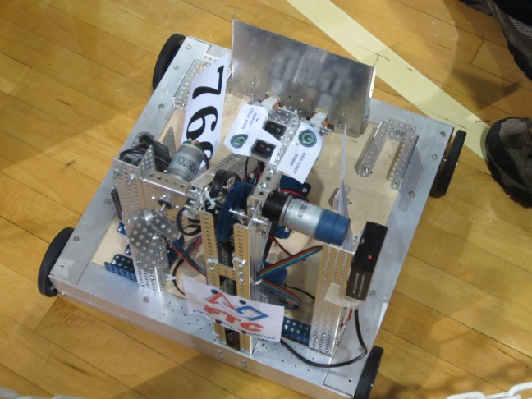We wish to thank you, Proto Manufacturing and Bauer Controls, for your generous support of our Robotics team. We could not have done it without you!

As you may recall F.I.R.S.T, stands for “For Inspiration & Recognition of Science & Technology” and is an organization that is dedicated to “creating a world where science and technology are celebrated” through motivational robotics programs for school- aged children. It is a volunteer driven program that relies on the generous donations of time, talent and resources from individuals and businesses around the world.

With your sponsorship, we were able to purchase the hardware we needed to construct our robot. In January we traveled to Ohio for the FTC competition there. We count it as a highly successful completion – we all learned a lot and are inspired to come back next year and improve our robot and skills.

Here is a team photo, taken at our competition in Columbus, Ohio.

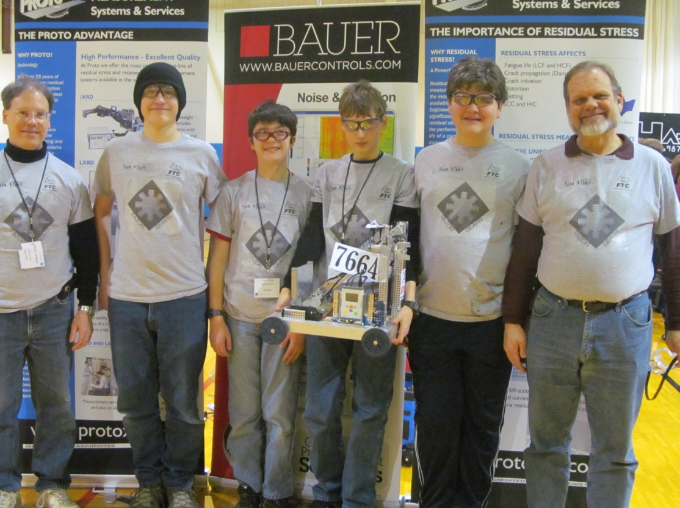

Coach, William Boyer, 6353 Merritt, Ypsilanti, MI 48197; [wslb@wboyer.net](mailto:wslb@wboyer.net) 734-481-3469